Table of Contents
1 Overview 2
2 Birthright Entitlement Identification 2
3 Joiner Lifecycle Event Population 3
4 One Time Joiner Processing 3
5 Implicit Joiner Triggers 4
6 Joiner Rehire LifeCycle Event Priority 4
7 Implicit Persona Trigger 4
8 Application Joiner Population Identification 5
9 Birthright Role 5
10 Manage User Access QuickLink Filtering 5
11 Manage Privileged Access QuickLink Filtering 6
12 Manager Notification 6
13 Joiner Process 6
14 Joiner Rehire Process 7
15 Joiner Return To Work Leave of Absence Process 8
16 Joiner Return To Work Long Term Disability Process 9
17 Joiner Process Priority 10
18 Joiner Reverse Leaver 10
19 Population Based Joiner Reverse Leaver Option 11
20 Joiner/Rehire Persona 11
21 Joiner Reverse Leaver Persona 12
22 Birthright Entitlement Manual Override 12
23 Process Attribute Synchronization After Rehire 12
24 Joiner and Rehire Password Email 12
25 Hide IdentityIQ Email Content 13
26 Notify Operations RTW LOA 13
27 Notify Operations RTW LTD 13

Document Revision History
Version | Date | Status | Author | Summary of Changes
Version 1 | 3/2/18 |  | Rohit Gupta
Version 2 | 4/4/18 |  | Cathy Mallet | Minor grammar/spelling/etc edit

Overview
The purpose of this document is to explain the technical details of the Joiner Feature that is bundled with the Accelerator Pack. This feature is configured via the Self Service Onboarding Wizard or the IdentityIQ Administrative Wizard. The Administrative Wizard can define “Extended Rule” and Java Regular Expression Options.

Birthright Entitlement Identification
Entitlement birthright status can be identified using String Format with Comparison Operation or String Format with Java Regular Expression. The name of the attribute that is used for this definition on an application is “birthrightEntAttrExpression”.

The “Rule-FrameWork-Promote-Managed-Attribute” rule must be selected as “Managed Entitlement Customization Rule” on an application. This rule is automatically set from the Self Service Onboarding Wizard.

During aggregation, the “Rule-FrameWork-Promote-Managed-Attribute” rule sets the entitlement attribute “isBirthright” to either “True” or “False” based on the privileged entitlement attribute “birthrightEntAttrExpression” identification. This rule executes only for new entitlements.

The “Rule-FrameWork-Group-Refresh” rule must be selected manually on all group type aggregations of an application. This rule executes for both new and old entitlements. This rule sets the entitlement attribute “isBirthright” to either “True” or “False” based on the privileged entitlement attribute “birthrightEntAttrExpression” identification.

Example of String Format with Operation “[Object Type(Optional).Schema Attribute Name]#IIQEntitlementBirthright#[Schema Attribute Value]#IIQEntitlementBirthright#[Operation]”. This format is automatically set from the Self Service Onboarding Wizard.

String Tokens and Separators | Description
[Object Type(Optional).Schema Attribute Name] | Some applications may support multiple Object Type Schemas for example Delimited File and JDBC connectors. The object type must be prefixed with the Application Schema Attribute Name
#IIQEntitlementBirthright# (Token Separator) | Token to Separate Identity Schema Attribute Name and Schema Attribute Value
[Schema Attribute Value] | Application Schema Attribute Value
#IIQEntitlementBirthright# (Token Separator) | Token to Separate Schema Attribute Value and Operation
[Operation] | STARTSWITH  ENDSWITH  CONTAINS  EQUALS

Example of String Format with Java Regular Expression “[Schema Attribute Name]#IIQEntitlementBirthright#[Java Regular Expression]”.

String Tokens and Separators | Description
[Object Type(Optional).Schema Attribute Name] | Some applications may support multiple Object Type Schemas for example Delimited File and JDBC connectors. The object type must be prefixed with the Application Schema Attribute Name
#IIQEntitlementBirthright# (Token Separator) | Token to Separate Application Schema Attribute Name and Java Regular Expression
[Java Regular Expression] | This is executed against the Application Schema Attribute Value obtained from Application Schema Attribute Name on the “Link” Object

The IdentityIQ Entitlement Catalog interface can be used to mark entitlements manually as birthright if they cannot be identified programmatically.

See the IdentityIQ Accelerator Pack Aggregation Document for managed entitlement customization rule “Rule-FrameWork-Promote-Managed-Attribute” and group refresh rule “Rule-FrameWork-Group-Refresh” section Aggregation Data Flow.

Joiner Lifecycle Event Population
The population named “New Joiner Has At Least One Birthright Account” is used as an implicit Joiner Lifecycle event trigger. Any Identity Cube that falls outside of this population is eligible for Joiner processing.

This population identifies Identity Cubes that are correlated and have at least one joiner or birthright account. This population queries correlated Identity Cubes and their account application’s “joinerEnabled” extended attribute.

Dynamic Filter of the GroupDefinition

<CompositeFilter operation="AND">
<Filter operation="EQ" property="links.application.joinerEnabled" ignoreCase="true" value="TRUE">
</Filter>
<Filter operation="EQ" property="correlated">
<Value>
<Boolean>true</Boolean>
</Value>
</Filter>
</CompositeFilter>

One Time Joiner Processing
A “needsJoiner” extended attribute is used to ensure that the Joiner Lifecycle Event is processed only once. This is used as an implicit Joiner Lifecycle Event. Before the Joiner event, the value of this attribute is “NEEDS PROCESSING”, and once the event is processed, the value of this attribute is set to “JOINER PROCESSED”.

The “Rule-FrameWork-Creation-Joiner-Authoritative-Source” rule must be set as a creation rule on all authoritative source applications. This rule is set automatically when the Joiner Lifecycle Event is configured via “Configure Triggers”. This rule sets the value of a “needsJoiner” extended attribute to ”NEEDS PROCESSING” for all new Identity Cubes.

This rule sets Identity User Type as Contractor (IdentityIQ 7.3) if account is aggregated from Contractor Repository, Identity User Type as Employee (IdentityIQ 7.3) if account is aggregated from Employee Repository. This rule sets Identity User Type as Service Account (IdentityIQ 7.3+) and set’s Service Cube Extended Attribute to True (IdentityIQ 7.2 + and IdentityIQ 7.3+) if account is aggregated from Service Account Repository. Please see Authoritative Applications Identification from Accelerator Pack Aggregation Document.

Repository can be authoritative source for both Employees and Contractors. In this case User Type must be set using Identity Mapping Rules and this rule will skip the User Type tagging.

Implicit Joiner Triggers

The Joiner Lifecycle Event is pre-configured with the Accelerator Pack. There are two AND conditions for the joiner workflow to be kicked off.
- An extended Attribute “needsJoiner” new value must be “NEEDS PROCESSING”, and the old value is “IGNORE”. This means any Identity Cube whose “needsJoiner” extended attribute value is “NEEDS PROCESSING” will be processed for Joiner.
- The Identity Cube must not be part of the population “New Joiner Has At Least One Birthright Account”

Additional Triggers can be configured for the Joiner Lifecycle Event using the “Configure Triggers” QuickLink. It could be based on the Identity Cube’s old and new attribute values or dates.

Joiner Rehire LifeCycle Event Priority
The Joiner Rehire Lifecycle Event has priority over Joiner Lifecycle Event. In case an identity is eligible for both joiner and rehire, only rehire event will be kicked off. This can happen for existing identities where joiner was never processed from IdentityIQ and identity doesn’t have any birthright account for example Active Directory application could delete accounts after certain period.

Implicit Persona Trigger
This is based on multi-valued extended attribute “relationships”. The addition of [ACTIVE] new relationship is considered a Joiner event. The “Rule-Framework-IdentityAttribute-Relationships” rule must be configured to set the multiple relationships/personas on an Identity Cube. Here are some examples of personas/relationships that can be set on an Identity Cube.

- EMPLOYEE [ACTIVE] (Jobe Code)
- EMPLOYEE [INACTIVE] (Jobe Code)
- EMPLOYEE [SUSPENDED] (Jobe Code)
- NON-EMPLOYEE [ACTIVE] (Vendor)
- NON-EMPLOYEE [INACTIVE] (Contractor)
- STUDENT [ACTIVE] (Campus Code–Program Name-School Name)
- STUDENT [INACTIVE] (Campus Code–Program Name-School Name)

This trigger is used in conjunction with Implicit Joiner Triggers. The Joiner event is triggered in the following order with an OR condition.
- Implicit Joiner Triggers
- Implicit Persona Trigger

Application Joiner Population Identification
This population identifies the Identity Cubes that requires birthright account and/or birthright roles on an application. This is defined on an application by the attribute name ”joinerPopulationRegex”. There are two supported formats for this attribute: one is String Format with Java Regular Expression and another is just the list of comma-separated group definition names. The list of group definition names is set automatically from the Self Service Onboarding Wizard.

Example of String Format with Java Regular Expression “[Cube Attribute Name]#IIQJoiner#[Java Regular Expression]”.

String Tokens and Separators | Description
[Cube Attribute Name] | Cube Attribute Name
#IIQJoiner# (Token Separator) | Token to Separate Cube Attribute Name and Java Regular Expression
[Java Regular Expression] | This is executed against the Cube Attribute Name Value obtained from Cube Attribute Name

An example of comma separated group definition names is ”Population Name1, Population Name 2”

Birthright Role
There is a separate role container for birthright roles named “Birthright Roles”. These roles are not auto-assigned by any assignment rule. The “No automatic assignment with rule” property on the “Birthright Roles” is checked. This ensures that these roles are not assigned during the Identity Refresh task option ”Provision Assignments”. These roles are assigned by the Joiner Workflow.

Please Note: The Application Joiner Population Identification as Java Regular Expression doesn’t support Birthright Roles. For Birthright roles, the application’s Joiner Population must be identified as single or multiple GroupDefinition.

These roles are not required by the Joiner Feature. Only joiner/birthright accounts will be created for applications that are joiner enabled and don’t have any joiner roles.
- They must be of role type “Birthright Roles”
- They must be configured with the extended attribute “isBirthright” value as “True”
- All the entitlements of Birthright Role must be configured with the extended attribute “isBirthright” value as “True”
- They must have the assignment rule set up as a population. This population must match the identity populations defined on the application. This will ensure every population gets its own birthright role; for example, the employee population gets the employee birthright role and the contractor population gets the contractor birthright role
The Self Service Onboarding Wizard uses a filter to display birthright roles.
Birthright Role Filter
Filter.and(Filter.eq("type", "Birthright Roles"), Filter.eq("disabled",false) ,Filter.ignoreCase(Filter.eq("isBirthright", "TRUE")), Filter.ignoreCase(Filter.in("profiles.application.name", Arrays.asList(<Selected Application>))));

Manage User Access QuickLink Filtering
The birthright entitlements and roles are filtered using object selector rules. By default, this QuickLink is configured for Help Desk, Manager, and Self-Service Dynamic Scopes.
- Rule-FrameWorkRegularRoles: This rule filters out birthright roles using following filter
  - Filter.or(Filter.isnull("isBirthright"), Filter.ignoreCase(Filter.eq("isBirthright", "FALSE")))
- Rule-FrameWorkRegularEntitlements: This rule filters out birthright entitlements using following filter
  - Filter.or(Filter.isnull("isBirthright"), Filter.ignoreCase(Filter.eq("isBirthright", "FALSE")))

Manage Privileged Access QuickLink Filtering
The birthright entitlements and roles are filtered using object selector rules. By default, this QuickLink is configured for Help Desk, Manager, and Self-Service Dynamic Scopes.

- Rule-FrameWorkPrivilegedRoles: This rule filters out birthright roles using following filter
  - Filter.or(Filter.isnull("isBirthright"), Filter.ignoreCase(Filter.eq("isBirthright", "FALSE")))
- Rule-FrameWorkPrivilegedEntitlements: This rule filters out birthright entitlements using following filter
  - Filter.or(Filter.isnull("isBirthright"), Filter.ignoreCase(Filter.eq("isBirthright", "FALSE")))

Manager Notification
Manager Notification is sent out to sponsor of the contractors or to the manager of employees during Joiner/Rehire/Reverse Leaver Lifecycle Event. Sponsor on contractor is detected using extended attribute "ctrMgr".

Notification can be cce’d to any workgroup using Global Definition “CC Email To Workgroup” configuration. In case, there is a requirement to cc email to different workgroups as per population, an extended rule can be used and referenced using Global Definition configuration “CC Email Rule” option.

Joiner Process
This process starts with an event which is set up with Implicit Joiner Triggers, which is described in the section above. Additional triggers can be configured using the “Configure Triggers” QuickLink. These additional triggers are based on the Identity Cube’s old and new attribute values or pre-hire date. This event kicks off the Joiner Workflow.

The same process can be kicked off manually by the Operations QuickLink “Process Identity Event”. This QuickLink is accessible to workgroup “Operations”.

This workflow builds a provisioning plan based on Joiner Enabled Applications. Here is the pseudo algorithm:
- Build Provisioning Plan with Birthright Account on Applications (No Populations and Birthright Roles Defined on Application)
- Build Provisioning Plan with Birthright Account (Populations or Java Regex Defined on Application)
  - Match Joiner Identity with single or multiple Populations defined on Application or Match using Java Regular Expression
- Build Provisioning Plan with Birthright Roles Defined on Application
  - Match Joiner Identity with single or multiple Populations defined on Application and Match Joiner Identity with Population of Birthright Roles.

There are some additional processing steps that are performed by this workflow
- Changes the implicit “Joiner Flag” value from “NEEDS PROCESSING” to “JOINER PROCESSED”
- Two emails are sent out to the manager; one for password and another one for account

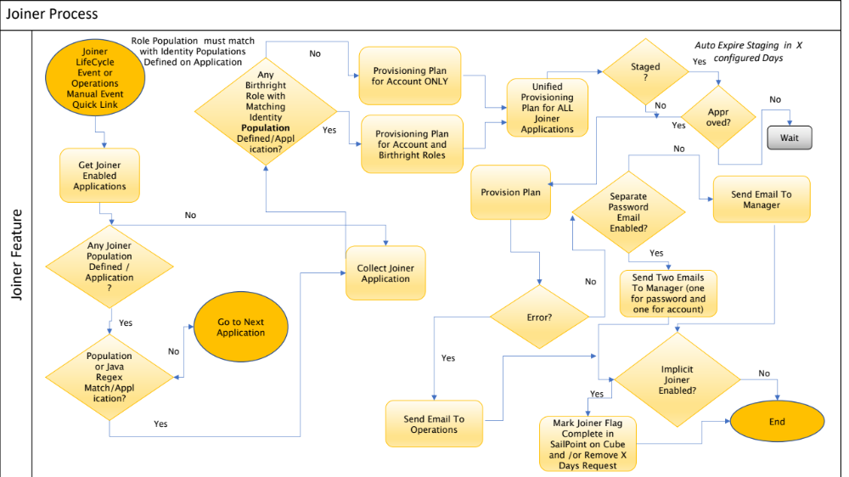

Joiner Rehire Process
This process starts with an event which can be configured using the “Configure Triggers” QuickLink. It is based on the Identity Cube’s old and new attribute values or pre-hire date. This event kicks off the Joiner Rehire Workflow.

The same process can be kicked off manually by the Operations QuickLink “Process Identity Event”. This QuickLink is accessible to the “Operations” workgroup.

This workflow builds a provisioning plan based on Joiner Enabled Applications and existing accounts on an Identity. Here is the pseudo algorithm:
- Build Provisioning Plan for existing account on an Identity based on Application’s Rehire Options
  - In case option is “Extended Rule”. Execute rule and merge Account Request into Provisioning Plan
- Build Provisioning Plan with Birthright Account on Applications (No Populations and Birthright Roles Defined on Application)
- Build Provisioning Plan with Birthright Account (Populations or Java Regex Defined on Application)
  - Match Joiner Identity with single or multiple Populations defined on Application or Match using Java Regular Expression
- Build Provisioning Plan with Birthright Roles Defined on Application
  - Match Joiner Identity with single or multiple Populations defined on Application and Match Joiner Identity with Population of Birthright Roles.

There are some additional processing steps that are performed by this workflow
- Executes a Global Rehire Before Plan Rule, if defined globally
- Runs Target Aggregation if the Move LDAP Account option is selected for Application
- Terminate X Days pending Leaver Request
- Two emails are sent out to the manager; one for password and another one for account

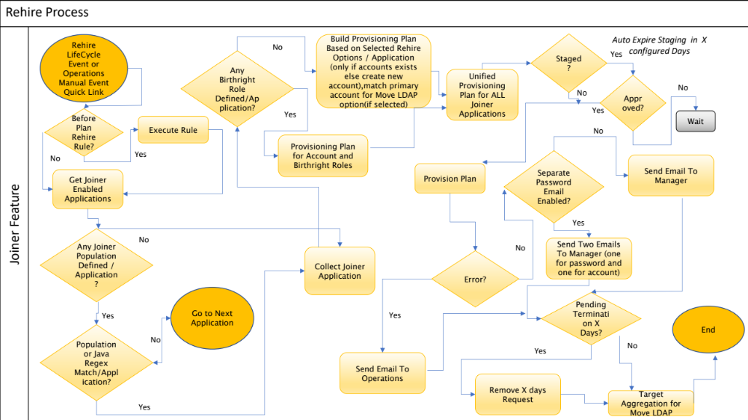

Joiner Return To Work Leave of Absence Process
This process starts with an event which can be configured using the “Configure Triggers” QuickLink. It is based on the Identity Cube’s old and new attribute values or recall of leave of absence date. This event kicks off the Joiner Return To Work Leave of Absence Workflow.

The same process can be kicked off manually by the Operations QuickLink “Process Identity Event”. This QuickLink is accessible to the “Operations” workgroup.

This workflow builds a provisioning plan based on existing accounts on an Identity. Here is the pseudo algorithm:
- Build Provisioning Plan for existing accounts on an Identity based on Application’s Return To Work Leave of Absence Options
  - If the option is “Extended Rule”, execute the rule and merge the Account Request into the Provisioning Plan

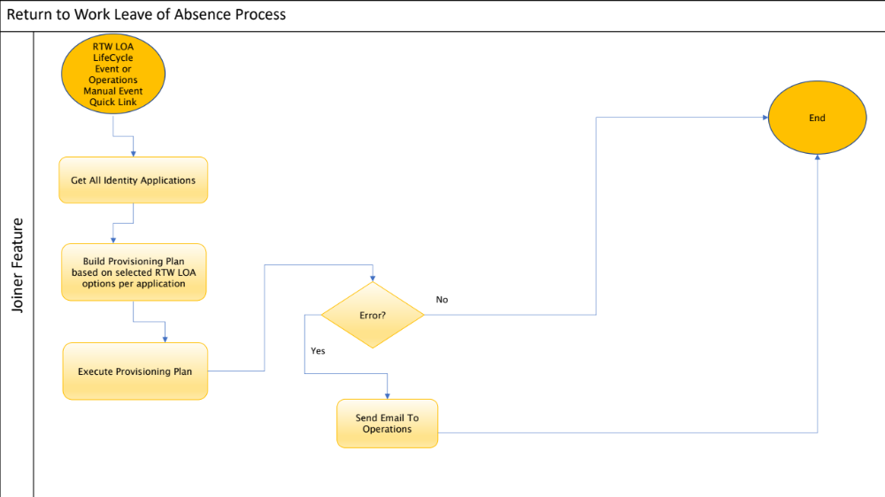

Joiner Return To Work Long Term Disability Process
This process starts with an event which can be configured using the “Configure Triggers” QuickLink. It is based on the Identity Cube’s old and new attribute values or recall of long-term disability date. This event kicks off the Joiner Return To Work Long Term Disability Workflow.

The same process can be kicked off manually by the Operations QuickLink “Process Identity Event”. This QuickLink is accessible to the “Operations” workgroup.

This workflow builds a provisioning plan based on existing accounts on an Identity. Here is the pseudo algorithm:
- Build Provisioning Plan for existing accounts on an Identity based on Application’s Return To Work Long-Term Disability Options
  - If the option is “Extended Rule”, execute the rule and merge the Account Request into the Provisioning Plan

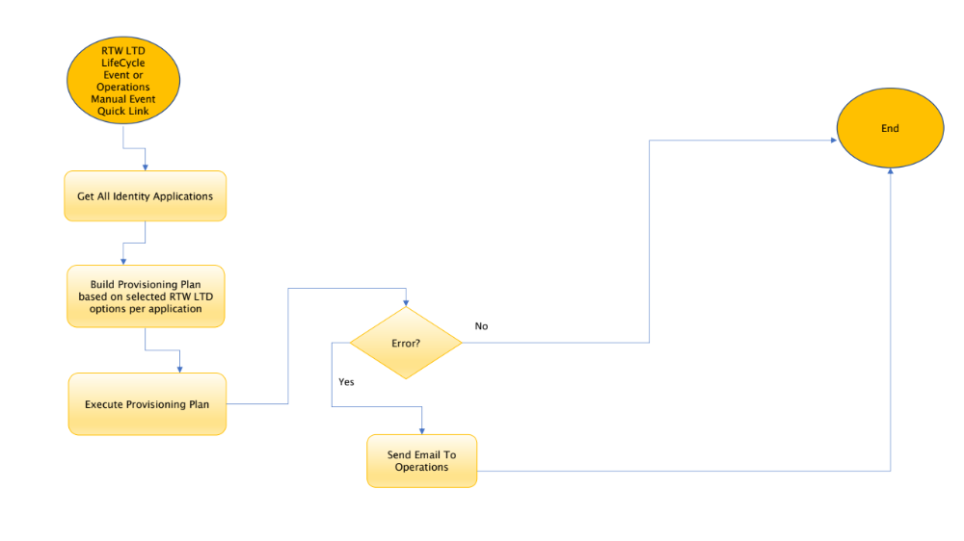

Joiner Process Priority
If an Identity is eligible for Rehire and Joiner process, Rehire Process gets priority over Joiner. This is to ensure existing Identities with joiner access do not go through joiner process again.

Joiner Reverse Leaver
This process starts with an event which can be configured using the “Configure Triggers” Quick Link. It is based on the Identity Cube’s old and new attribute values or recall of leaver date. This event kicks off the Joiner Reverse Leaver Workflow.

The same process can be kicked off manually by the Operations Quick Link “Process Identity Event”. This Quick Link is accessible to the “Operations” workgroup.

This workflow builds a provisioning plan based on existing accounts on an Identity. Here is the pseudo algorithm:
- Build Provisioning Plan for existing accounts on an Identity based on Application’s Reverse Leaver Options
  - If the option is “Extended Rule”, execute the rule and merge the Account Request into the Provisioning Plan

There are some additional processing steps that are performed by this workflow
- Run Target Aggregation if the Move LDAP Account option is selected for the Application
- Re-assign Birthright Roles that were removed during termination if Restore Birthright Access option is selected for the Application
- Terminate X Days pending Leaver Request

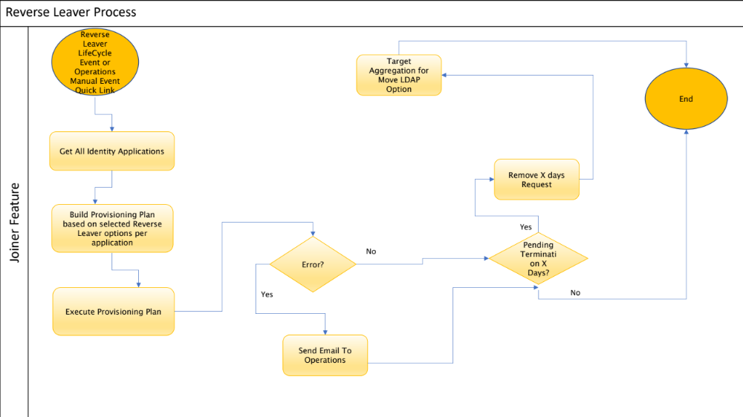

Population Based Joiner Reverse Leaver Option
Reverse Leaver Options can be defined per population on an application. This can be configured on an application from the Debug Page. These options gets priority over Reverse Leaver options that can be defined on an application using Self Service Onboarding Wizard. Multiple populations can be defined for Reverse Leaver process. In case reverse leaver identity matches multiple population, first matched population options will be used for Reverse Leaver. Here is an example of population options.

<entry key=“apPopulationReverseLeaverOptions”>
<value>
<List>
<Map>
<entry key=“apReversePopulation” value=“Population 1”/>
<entry key=“apReverseTerminationOption” value=“Restore All Access Immediately”/>
<entry key=“apReverseTerminationExtendedRule” value=""/>
</Map>

<Map>
<entry key=“apReversePopulation” value=“Population 2”/>
<entry key=“apReverseTerminationOption” value=“Enable Immediately”/>
<entry key=“apReverseTerminationExtendedRule” value=""/>
</Map>
</List>
</value>
</entry>

Joiner/Rehire Persona
When persona feature is enabled, Joiner/Rehire process gets kicked off either when personas are added to an Identity or based on Lifecycle Event Triggers. Addition of personas are calculated based on Identity’s “relationships” attribute. Sample rule “Rule-Framework-IdentityAttribute-Relationships” packaged with Accelerator Pack must be used as a reference to define personas on an identity. Here is an example of personas that are added to an identity. Either keyword [ACTIVE] or addition of persona on “relationships” attribute is considered as persona add.

Identity Relationships
EMPLOYEE [ACTIVE] (FTE1)
EMPLOYEE [ACTIVE] (FTE2)
STUDENT [ACTIVE] (100-Health Science-RIT)

Note: Joiner Access for Joiner enabled applications is recalculated and assigned/unassigned to an identity during persona addition

Joiner Reverse Leaver Persona

Reverse Leaver process gets kicked off only when all personas are added back to an Identity. When persona feature is enabled, triggers defined based on authoritative sources are not used for Reverse Leaver process. Addition of personas are calculated based on Identity’s “relationships” attribute. Sample rule “Rule-Framework-IdentityAttribute-Relationships” packaged with Accelerator Pack must be used as a reference to define personas on an identity. Here is an example of personas that are added back to an identity. Either keyword [ACTIVE] or addition of persona on “relationships” attribute is considered as persona add.

Identity Relationships
EMPLOYEE [ACTIVE] (FTE1)
EMPLOYEE [ACTIVE] (FTE2)
STUDENT [ACTIVE] (100-Health Science-RIT)

Birthright Entitlement Manual Override
This sub-feature is mainly used by the operations team to override the tagging of birthright entitlements programmatically. The IdentityIQ Entitlement Catalog interface can be used to mark birthright entitlements as not birthright. This can be done by setting the value “FALSE” for the “Birthright Entitlements” extended attribute. To ensurethis value is not overridden, the next time the group refresh rule “Rule-FrameWork-Group-Refresh” executes, the “Manual Override” attribute must be set to “TRUE”. By default, an empty value for this attribute means “FALSE”.

Process Attribute Synchronization After Rehire
By default, Attribute Synchronization has priority over Joiner Rehire Lifecycle Event. As a result, this option provides flexibility to run attribute synchronization after rehire event. If this option is checked for an application, attribute synchronization process per application is executed after rehire process.

Note: Attribute Synchronization can be executed in parallel with Joiner Rehire Lifecycle Event. This can be configured using Global Definitions option “Rehire and Attribute Synchronization Parallel Processing”. If this option is checked at global level, then there is no need to check “Process Attribute Synchronization After Rehire” per application.

Joiner and Rehire Password Email
During onboarding of an application for Joiner Feature via Self Service Onboarding Wizard, email instructions that are entered on a joiner form are suffixed with create provisioning policy password field name. These email instructions are saved in a custom artifact “Custom-Framework-EmailTextMapping” automatically with velocity “$” for example [Instructions]<Welcome New User>+[Velocity Dollar Sign]<$>+[Field Name]<Password>.
Please Note: The password field must be of type “secret” defined on an application create provisioning policy.

Hide IdentityIQ Email Content
Joiner, Joiner Rehire, Reverse Leaver Emails to Manager can be configured using Global Definitions option “Disable Static Email Content on Manager Emails“ to hide IdentityIQ specific content.

Notify Operations RTW LOA
By Default, Return To Work LOA Email is sent out to Operations on provisioning failures only. A Global Definition Configuration "Notify Operations on Return To Work LOA for an Identity" can be used to send out email to Operations on RTW LOA provisioning action.

If there is a requirement to cc this email, an extended rule can be used and referenced using Global Definition configuration “CC Email Rule” option.

Notify Operations RTW LTD
By Default, Return To Work LTD Email is sent out to Operations on provisioning failures only. A Global Definition Configuration "Notify Operations on Return To Work LTD for an Identity" can be used to send out email to Operations on RTW LTD provisioning action.

If there is a requirement to cc this email, an extended rule can be used and referenced using Global Definition configuration “CC Email Rule” option.

